Report of Sizzling Seven
19th July 2019,
The event was diligently organized. There was a soul to it. A soul that was vibrant, contagious and exuberant. The event name was Sizzling Seven.
In this event there were seven games namely:
1)Gems 2) Junk in the trunk 3)Chop sticks 4)Head to Head 5)Moving it up 6)Catch it up 7)Stack attack
The venue was Lenco hall and 7 teams registered themselves, in one team there were five members. And one team was declared as winner team.
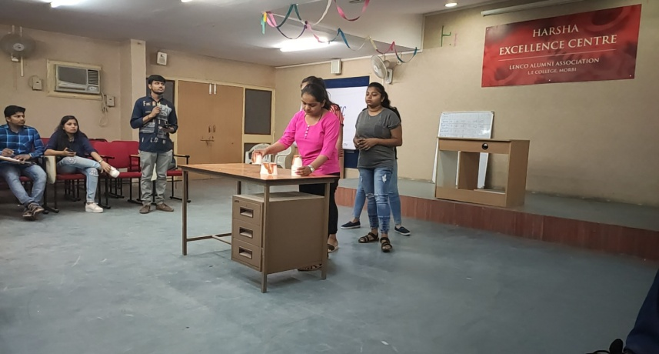 | 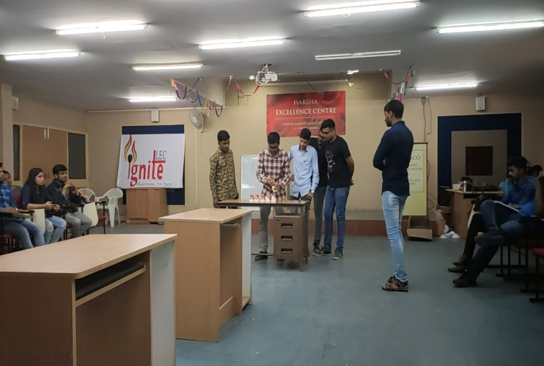
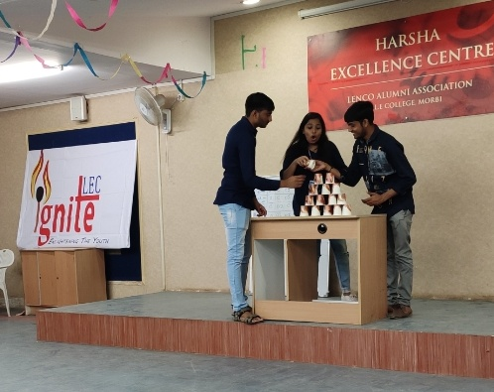
Stack Attack

The first year students, who came just two days before, also participated and were very excited. The event was all about their excitement and happiness. And the participants as well as the audience were very satisfied and enjoyed a lot.
We really enjoyed a lot and dispersed with a sincere hope that such events should be organized time and again giving the students a chance to display their talents.

